N-gonal Prism
# Source: AI Source: Provided by: [Data Path: Persons Table -> ID Column: 1, Name_En Column: Motasem Essam] -> From: [ChatGPT] on [7/25/2026]
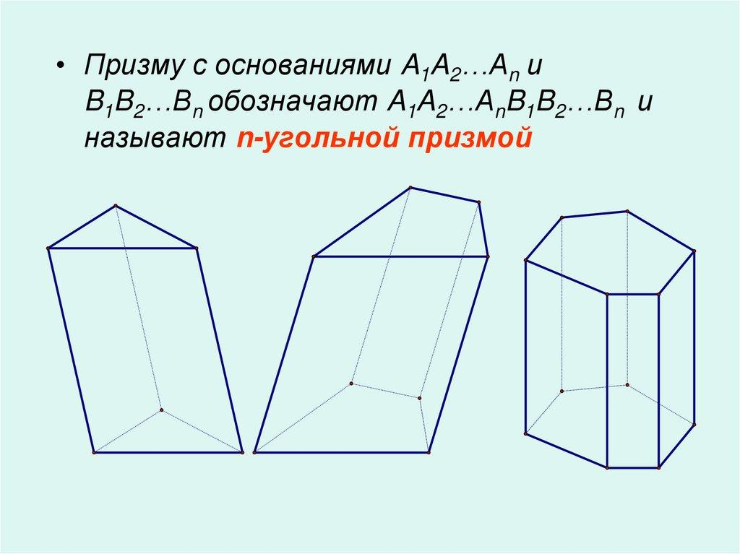
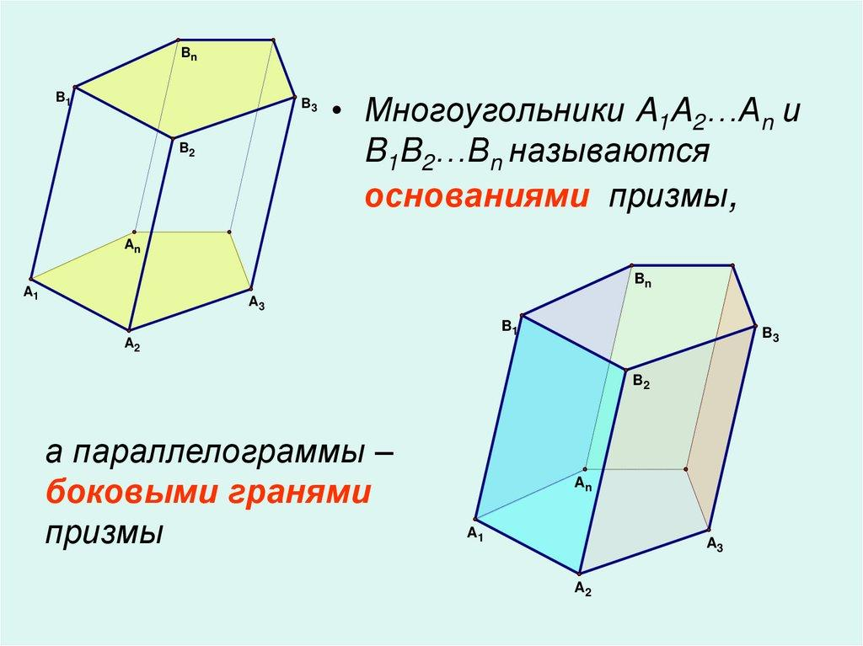
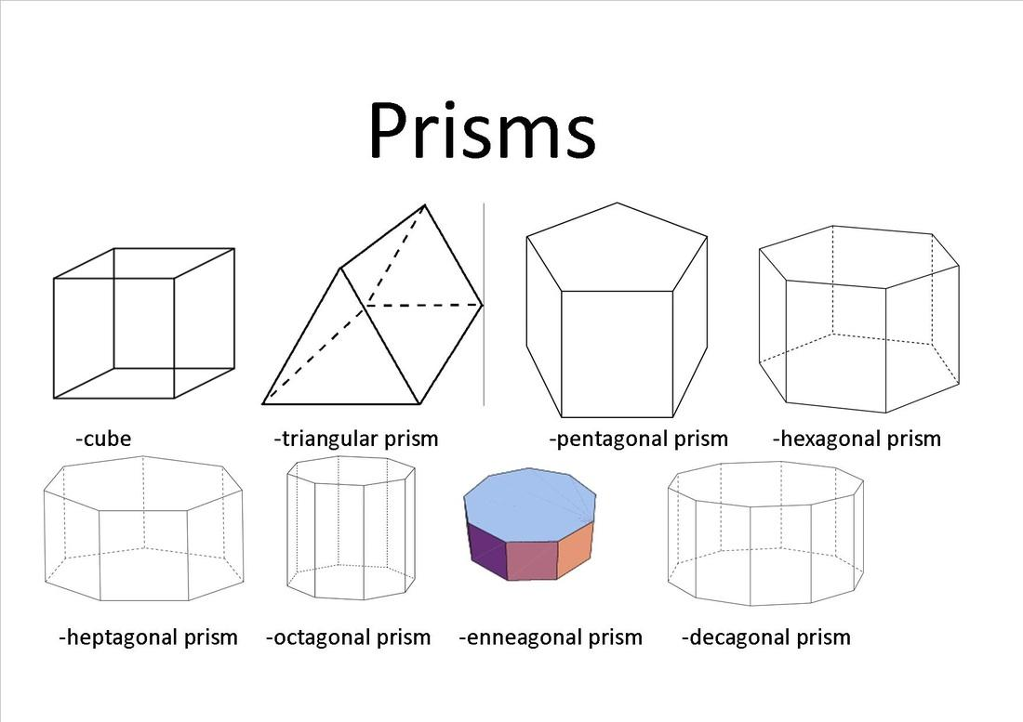

Definition
# Source: AI Source: Provided by: [Data Path: Persons Table -> ID Column: 1, Name_En Column: Motasem Essam] -> From: [ChatGPT] on [7/25/2026]
An n-gonal prism is a three-dimensional polyhedron with two congruent, parallel bases, each shaped like an $n$-sided polygon, connected by $n$ lateral faces.
The letter $n$ represents the number of sides of the polygonal base, where $n$ is an integer greater than or equal to 3.
For example:
- $n=3$: Triangular prism
- $n=4$: Quadrilateral prism
- $n=5$: Pentagonal prism
- $n=6$: Hexagonal prism
- $n=7$: Heptagonal prism
- $n=8$: Octagonal prism
An n-gonal prism can be a right prism, whose lateral edges are perpendicular to the bases, or an oblique prism, whose lateral edges are inclined to the bases.

Simple Definition
# Source: AI Source: Provided by: [Data Path: Persons Table -> ID Column: 1, Name_En Column: Motasem Essam] -> From: [ChatGPT] on [7/25/2026]
An n-gonal prism is a solid with two identical, parallel polygons, each having $n$ sides, joined by $n$ side faces.
The value of $n$ determines the shape of the bases and the number of faces, edges, and vertices.

Classification Tree
# Source: AI Source: Provided by: [Data Path: Persons Table -> ID Column: 1, Name_En Column: Motasem Essam] -> From: [ChatGPT] on [7/25/2026]
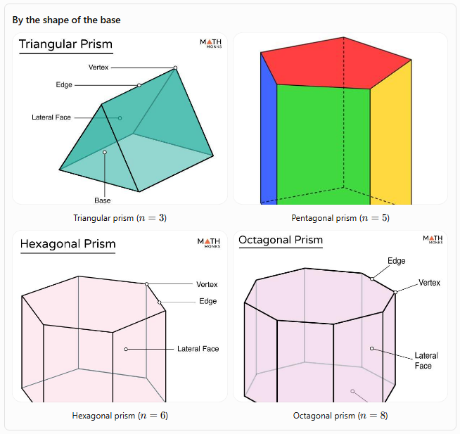By the shape of the base
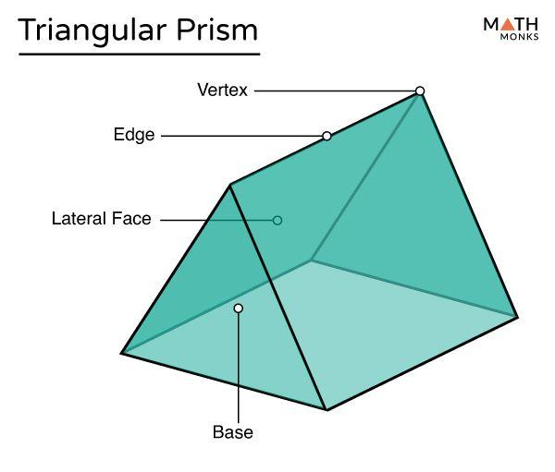
Triangular prism (\(n=3\))
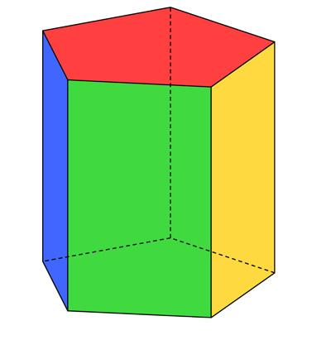
Pentagonal prism (\(n=5\))
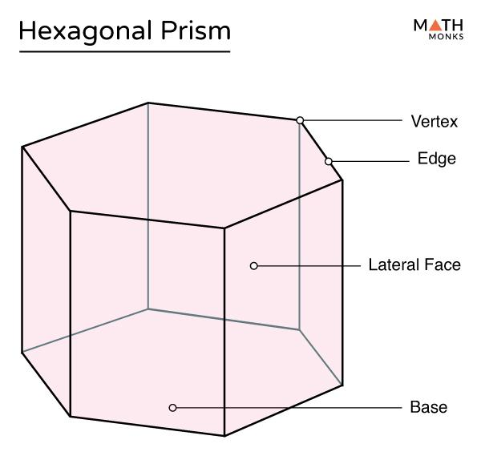
Hexagonal prism (\(n=6\))
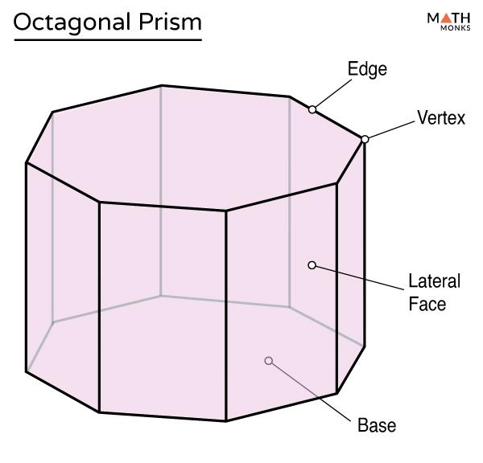
Octagonal prism (\(n=8\))
By orientation
- Right n-gonal prism
- Oblique n-gonal prism
By the base polygon
- Regular-base prism
- Irregular-base prism
These classifications describe different properties. For example, a right prism can have either regular or irregular polygonal bases.

Key Characteristics
# Source: AI Source: Provided by: [Data Path: Persons Table -> ID Column: 1, Name_En Column: Motasem Essam] -> From: [ChatGPT] on [7/25/2026]
For an n-gonal prism, the number of faces, edges, and vertices depends directly on $n$.
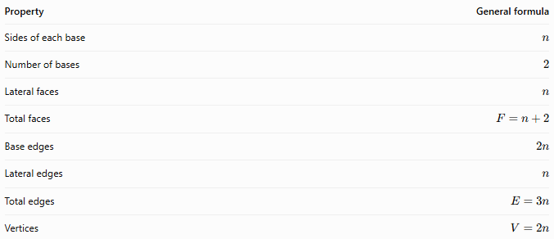
Property | General formula
Sides of each base | $$n$$
Number of bases | $$2$$
Lateral faces | $$n$$
Total faces | $$F=n+2$$
Base edges | $$2n$$
Lateral edges | $$n$$
Total edges | $$E=3n$$
Vertices | $$V=2n$$
Important: These formulas apply to ordinary prisms with polygonal bases and the usual face, edge, and vertex structure.

Geometric Representation
# Source: AI Source: Provided by: [Data Path: Persons Table -> ID Column: 1, Name_En Column: Motasem Essam] -> From: [ChatGPT] on [7/25/2026]
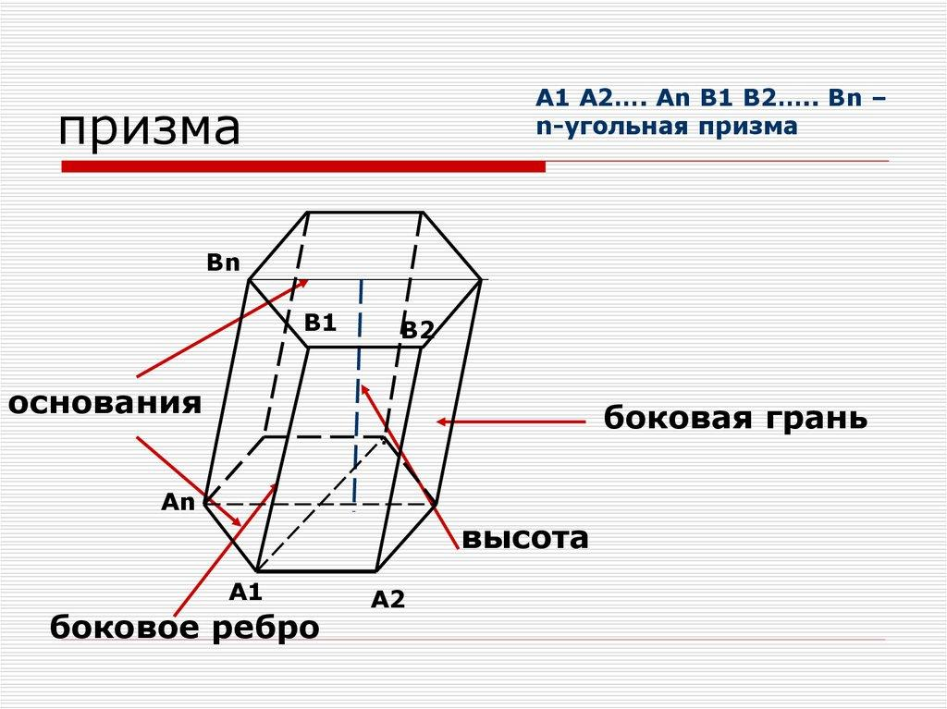
An n-gonal prism consists of the following components:
- Two bases: Congruent, parallel $n$-sided polygons.
- Lateral faces: $n$ faces joining corresponding edges of the bases.
- Base edges: Each base has $n$ edges, giving $2n$ in total.
- Lateral edges: $n$ edges connecting corresponding vertices.
- Vertices: Each base has $n$ vertices, giving $2n$ in total.
- Height: The perpendicular distance between the two base planes.
In a right prism, the lateral faces are rectangles. In an oblique prism, they are parallelograms.

Mathematical Representations and Formulas
# Source: AI Source: Provided by: [Data Path: Persons Table -> ID Column: 1, Name_En Column: Motasem Essam] -> From: [ChatGPT] on [7/25/2026]
Let:
- $n$ = number of sides of each base
- $B$ = area of one base
- $p$ = perimeter of one base
- $h$ = perpendicular height of the prism
- $A_{L}$ = lateral surface area
- $A_{T}$ = total surface area
- $V_{\text{solid}}$ = volume

A. Number of faces
# Source: AI Source: Provided by: [Data Path: Persons Table -> ID Column: 1, Name_En Column: Motasem Essam] -> From: [ChatGPT] on [7/25/2026]
The two bases contribute two faces, and the prism has $n$ lateral faces.
$$\boxed{F=n+2}$$

B. Number of edges
# Source: AI Source: Provided by: [Data Path: Persons Table -> ID Column: 1, Name_En Column: Motasem Essam] -> From: [ChatGPT] on [7/25/2026]
Each base has $n$ edges, so the two bases have $2n$ base edges. There are also $n$ lateral edges.
$$E=2n+n$$
$$\boxed{E=3n}$$

C. Number of vertices
# Source: AI Source: Provided by: [Data Path: Persons Table -> ID Column: 1, Name_En Column: Motasem Essam] -> From: [ChatGPT] on [7/25/2026]
Each base has $n$ vertices. Since there are two bases:
$$\boxed{V=2n}$$

D. Euler's formula
# Source: AI Source: Provided by: [Data Path: Persons Table -> ID Column: 1, Name_En Column: Motasem Essam] -> From: [ChatGPT] on [7/25/2026]
For a convex n-gonal prism:
$$V-E+F=2$$
Substituting the general formulas:
$$2n-3n+\left(n+2\right)=2$$
Simplifying:
$$\boxed{2=2}$$
Therefore, the formulas for faces, edges, and vertices satisfy Euler's formula.

E. Volume
# Source: AI Source: Provided by: [Data Path: Persons Table -> ID Column: 1, Name_En Column: Motasem Essam] -> From: [ChatGPT] on [7/25/2026]
The volume of any prism is its base area multiplied by its perpendicular height:
$$\boxed{V_{\text{solid}}=Bh}$$
This formula applies to both right and oblique prisms.

F. Lateral surface area
# Source: AI Source: Provided by: [Data Path: Persons Table -> ID Column: 1, Name_En Column: Motasem Essam] -> From: [ChatGPT] on [7/25/2026]
For a right prism:
$$\boxed{A_{L}=ph}$$
This is the base perimeter multiplied by the perpendicular height.
For an oblique prism, the lateral surface area is the sum of the actual areas of the $n$ lateral parallelograms.

G. Total surface area
# Source: AI Source: Provided by: [Data Path: Persons Table -> ID Column: 1, Name_En Column: Motasem Essam] -> From: [ChatGPT] on [7/25/2026]
The total surface area consists of the lateral surface area and the two bases:
$$\boxed{A_{T}=A_{L}+2B}$$
For a right prism:
$$\boxed{A_{T}=ph+2B}$$

H. Regular n-gonal base
# Source: AI Source: Provided by: [Data Path: Persons Table -> ID Column: 1, Name_En Column: Motasem Essam] -> From: [ChatGPT] on [7/25/2026]
If the base is a regular $n$-gon with side length $a$ and apothem $r$, its perimeter is
$$p=na$$
Its area is
$$\boxed{B=\frac{12}{p}r=\frac{12}{n}ar}$$
For $n≥3$, the apothem of a regular polygon with side length $a$ is
$$r=\frac{a}{2\tan\left(π/n\right)}$$
Thus, the base area can also be written as
$$\boxed{B=\frac{na^{2}}{4\tan\left(π/n\right)}}$$
The volume of a right prism with this regular base is
$$\boxed{V_{\text{solid}}=\frac{na^{2}h}{4\tan\left(π/n\right)}}$$

Worked Examples
# Source: AI Source: Provided by: [Data Path: Persons Table -> ID Column: 1, Name_En Column: Motasem Essam] -> From: [ChatGPT] on [7/25/2026]
Example 1: Finding the number of faces, edges, and vertices
Problem: Find the number of faces, edges, and vertices of a heptagonal prism.
A heptagon has seven sides, so $n=7$.
Step 1: Calculate the faces.
$$F=n+2=7+2=\boxed{9}$$
Step 2: Calculate the edges.
$$E=3n=3\left(7\right)=\boxed{21}$$
Step 3: Calculate the vertices.
$$V=2n=2\left(7\right)=\boxed{14}$$
Answer: A heptagonal prism has 9 faces, 21 edges, and 14 vertices.
Example 2: Identifying a prism from its number of faces
Problem: An n-gonal prism has 12 faces. Find the number of sides of each base.
The general formula is
$$F=n+2$$
Substitute $F=12$:
$$12=n+2$$
$$n=12-2$$
$$\boxed{n=10}$$
Answer: Each base is a decagon, so the solid is a decagonal prism.
Example 3: Finding the number of edges from the number of vertices
Problem: An n-gonal prism has 20 vertices. Find the number of edges and faces.
Since
$$V=2n$$
we have
$$20=2n$$
$$n=10$$
The number of edges is
$$E=3n=3\left(10\right)=\boxed{30}$$
The number of faces is
$$F=n+2=10+2=\boxed{12}$$
Answer: The prism has 30 edges and 12 faces.
Example 4: Calculating volume
Problem: An n-gonal prism has a base area of $45{\text{ cm}}^{2}$ and a perpendicular height of $8\text{ cm}$. Find its volume.
Using the general prism volume formula:
$$V_{\text{solid}}=Bh$$
Substitute the values:
$$V_{\text{solid}}=45×8$$
$$\boxed{V_{\text{solid}}=360{\text{ cm}}^{3}}$$
Answer: $360{\text{ cm}}^{3}$.
Notice that the volume formula does not depend on the number of sides directly. The base area already accounts for the shape of the polygon.
Example 5: Calculating surface area of a right prism
Problem: A right n-gonal prism has a base perimeter of $24\text{ cm}$, a base area of $30{\text{ cm}}^{2}$, and a height of $7\text{ cm}$. Find its total surface area.
First, calculate the lateral surface area:
$$A_{L}=ph$$
$$A_{L}=24×7=168{\text{ cm}}^{2}$$
Then calculate the total surface area:
$$A_{T}=A_{L}+2B$$
$$A_{T}=168+2\left(30\right)$$
$$\boxed{A_{T}=228{\text{ cm}}^{2}}$$
Answer: $228{\text{ cm}}^{2}$.

Comparison with Specific Types of Prisms
# Source: AI Source: Provided by: [Data Path: Persons Table -> ID Column: 1, Name_En Column: Motasem Essam] -> From: [ChatGPT] on [7/25/2026]
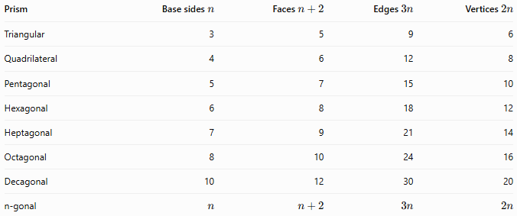
Prism | Base sides $n$ | Faces $n+2$ | Edges $3n$ | Vertices $2n$
Triangular | 3 | 5 | 9 | 6
Quadrilateral | 4 | 6 | 12 | 8
Pentagonal | 5 | 7 | 15 | 10
Hexagonal | 6 | 8 | 18 | 12
Heptagonal | 7 | 9 | 21 | 14
Octagonal | 8 | 10 | 24 | 16
Decagonal | 10 | 12 | 30 | 20
n-gonal | $$n$$ | $$n+2$$ | $$3n$$ | $$2n$$
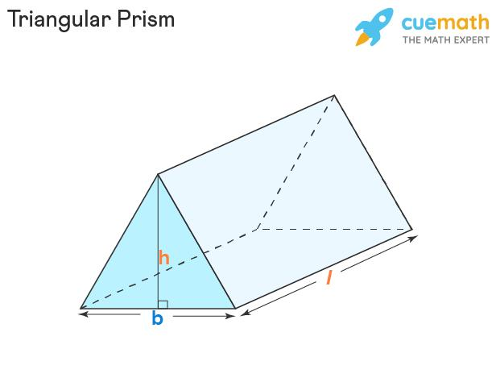
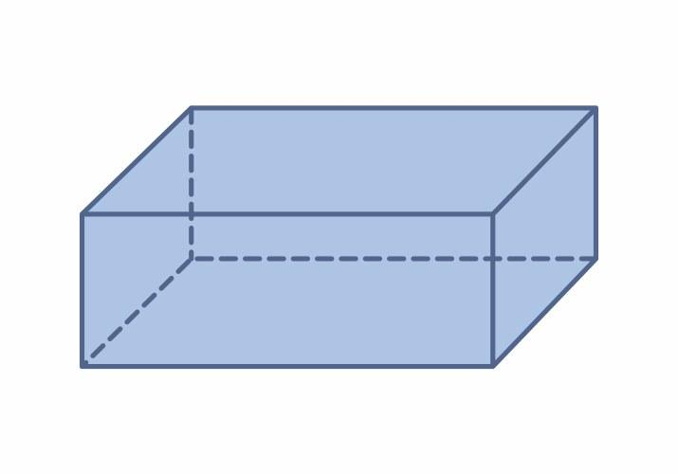
The table shows a consistent pattern: increasing the number of sides of the base by one adds one face, three edges, and two vertices.

Constructing N-gonal Pyramid in Solid Geometry

Instruments Used
# Source: AI Source: Provided by: [Data Path: Persons Table -> ID Column: 1, Name_En Column: Motasem Essam] -> From: [ChatGPT] on [7/25/2026]
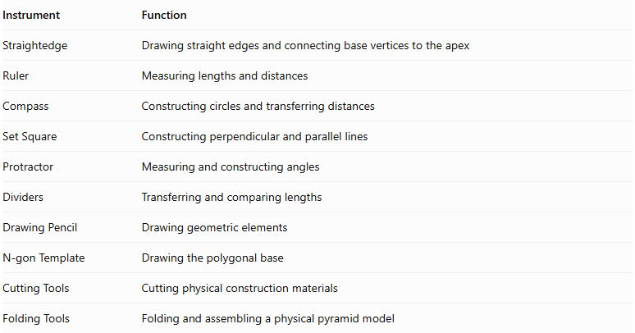
Instrument | Function
Straightedge | Drawing straight edges and connecting base vertices to the apex
Ruler | Measuring lengths and distances
Compass | Constructing circles and transferring distances
Set Square | Constructing perpendicular and parallel lines
Protractor | Measuring and constructing angles
Dividers | Transferring and comparing lengths
Drawing Pencil | Drawing geometric elements
N-gon Template | Drawing the polygonal base
Cutting Tools | Cutting physical construction materials
Folding Tools | Folding and assembling a physical pyramid model

Construction Procedures

Right N-gonal Pyramid Construction
# Source: AI Source: Provided by: [Data Path: Persons Table -> ID Column: 1, Name_En Column: Motasem Essam] -> From: [ChatGPT] on [7/25/2026]
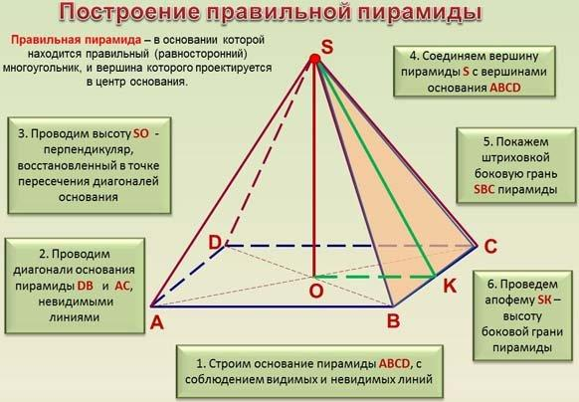
- Construct the required regular or irregular $n$-sided polygonal base.
- Determine the center of the base when constructing a right pyramid.
- Construct a perpendicular line to the base plane through its center.
- Determine the required pyramid height.
- Mark the apex on the perpendicular line.
- Connect the apex to every vertex of the base.
- Complete the $n$ triangular lateral faces.
- Identify the visible and hidden edges to complete the geometric representation.

Oblique N-gonal Pyramid Construction
# Source: AI Source: Provided by: [Data Path: Persons Table -> ID Column: 1, Name_En Column: Motasem Essam] -> From: [ChatGPT] on [7/25/2026]
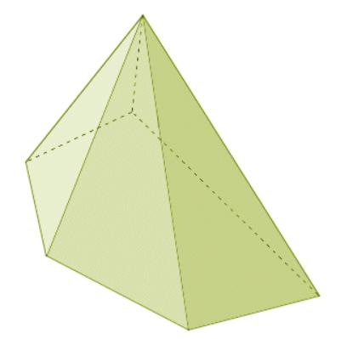
- Construct the required polygonal base.
- Determine the desired position of the apex away from the base center.
- Establish the required height and inclination.
- Mark the apex at the selected spatial position.
- Connect the apex to every vertex of the base.
- Complete the $n$ triangular lateral faces.
- Identify the visible and hidden edges.

Net-Based Construction
# Source: AI Source: Provided by: [Data Path: Persons Table -> ID Column: 1, Name_En Column: Motasem Essam] -> From: [ChatGPT] on [7/25/2026]
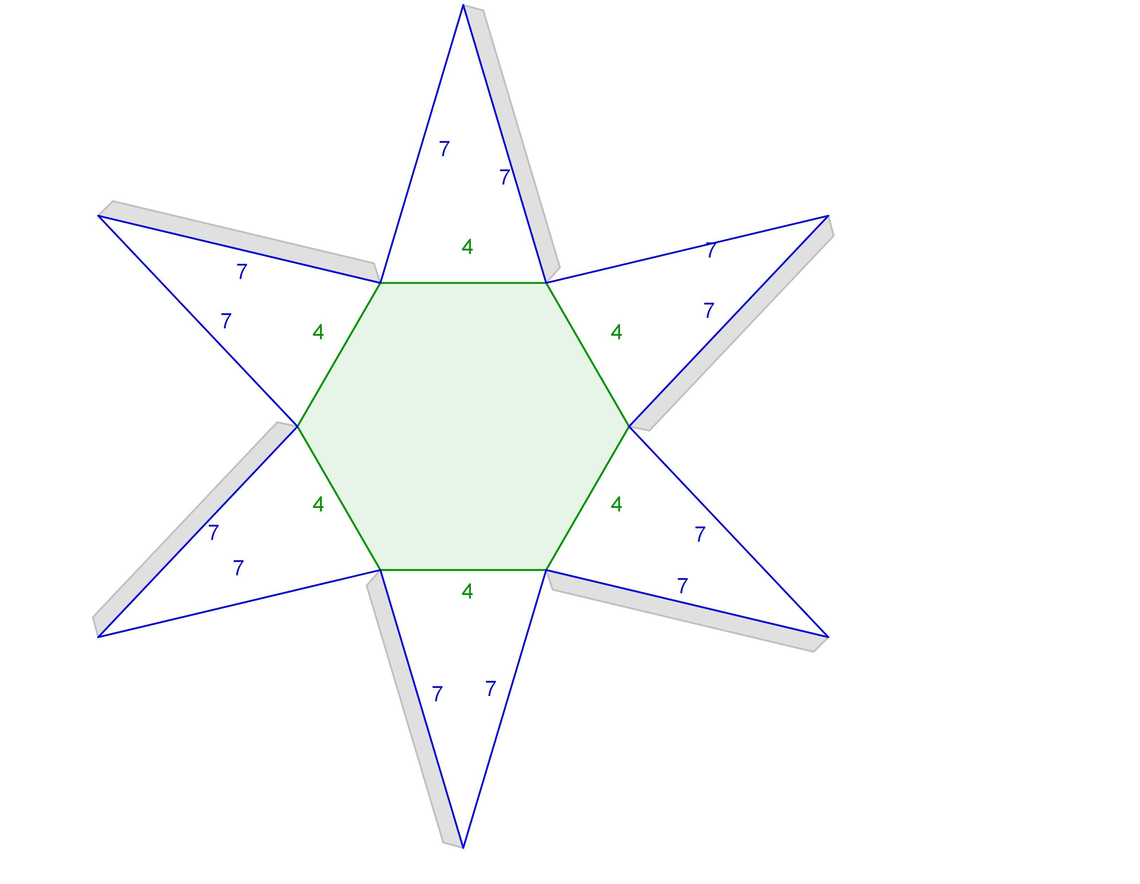
- Construct one polygonal base with $n$ sides.
- Construct $n$ triangular lateral faces.
- Attach one triangular face to each edge of the base.
- Arrange the triangles around the polygonal base.
- Add joining tabs if required for physical assembly.
- Cut out the net.
- Fold the triangular faces upward.
- Join the lateral edges to form the pyramid.

Face-Based Construction
# Source: AI Source: Provided by: [Data Path: Persons Table -> ID Column: 1, Name_En Column: Motasem Essam] -> From: [ChatGPT] on [7/25/2026]
- Construct the polygonal base.
- Determine the apex position.
- Connect the apex to all base vertices.
- Construct each triangular lateral face.
- Verify that adjacent lateral faces share the appropriate lateral edges.
- Complete the geometric representation.

Applications of n-gonal Prisms
# Source: AI Source: Provided by: [Data Path: Persons Table -> ID Column: 1, Name_En Column: Motasem Essam] -> From: [ChatGPT] on [7/25/2026]
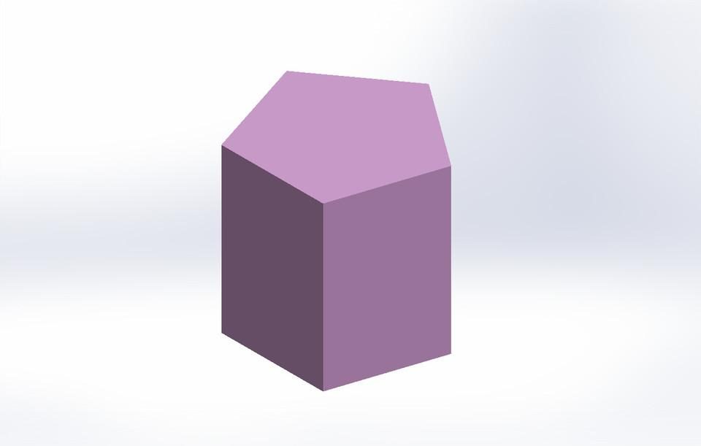
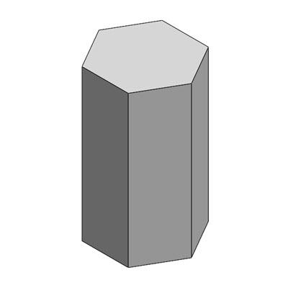
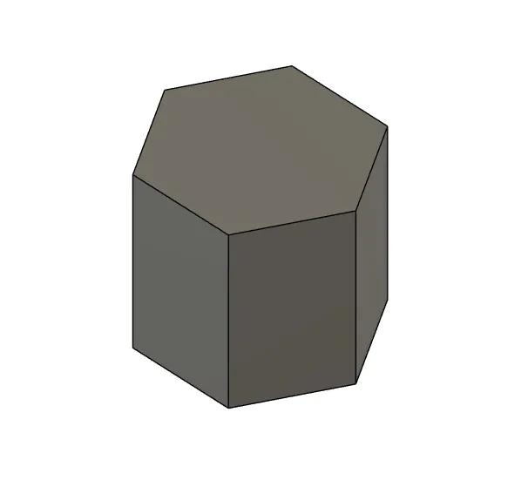
N-gonal prisms are useful in several fields:
- Architecture: Modeling columns, beams, and structures with polygonal cross-sections.
- Engineering: Representing components with constant polygonal cross-sections.
- Packaging and product design: Designing containers and objects with polygonal profiles.
- Mathematics education: Demonstrating the relationship between a base polygon's sides and a solid's faces, edges, and vertices.
- Computer graphics: Building three-dimensional polygonal models for rendering and simulation.

Key Points
# Source: AI Source: Provided by: [Data Path: Persons Table -> ID Column: 1, Name_En Column: Motasem Essam] -> From: [ChatGPT] on [7/25/2026]
- An n-gonal prism has two congruent, parallel $n$-sided polygonal bases.
- The number of lateral faces is $n$.
- The total number of faces is $F=n+2$.
- The total number of edges is $E=3n$.
- The total number of vertices is $V=2n$.
- The volume is $V_{\text{solid}}=Bh$.
- For a right prism, the lateral surface area is $A_{L}=ph$.
- The total surface area is $A_{T}=A_{L}+2B$.
- Every convex n-gonal prism satisfies Euler's formula $V-E+F=2$.

Conclusion
# Source: AI Source: Provided by: [Data Path: Persons Table -> ID Column: 1, Name_En Column: Motasem Essam] -> From: [ChatGPT] on [7/25/2026]
An n-gonal prism is the general form of a prism whose bases are congruent, parallel polygons with $n$ sides. It provides a single mathematical model for understanding triangular, quadrilateral, pentagonal, hexagonal, and other polygonal prisms.
The number of sides of the base determines the structure of the solid: an n-gonal prism has $n+2$ faces, $3n$ edges, and $2n$ vertices. Its volume is the base area multiplied by its perpendicular height, while its total surface area includes the lateral faces and both bases.
These general formulas make it possible to analyze prisms without studying every type separately. By substituting the appropriate value of $n$, the same principles can be applied to any ordinary prism with a polygonal base.

